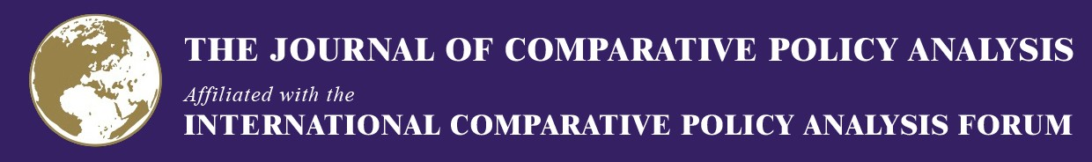

WORKSHOP PROGRAM

The 15th Annual JCPA and ICPA Forum Workshop
Comparing Third Sector Expansions
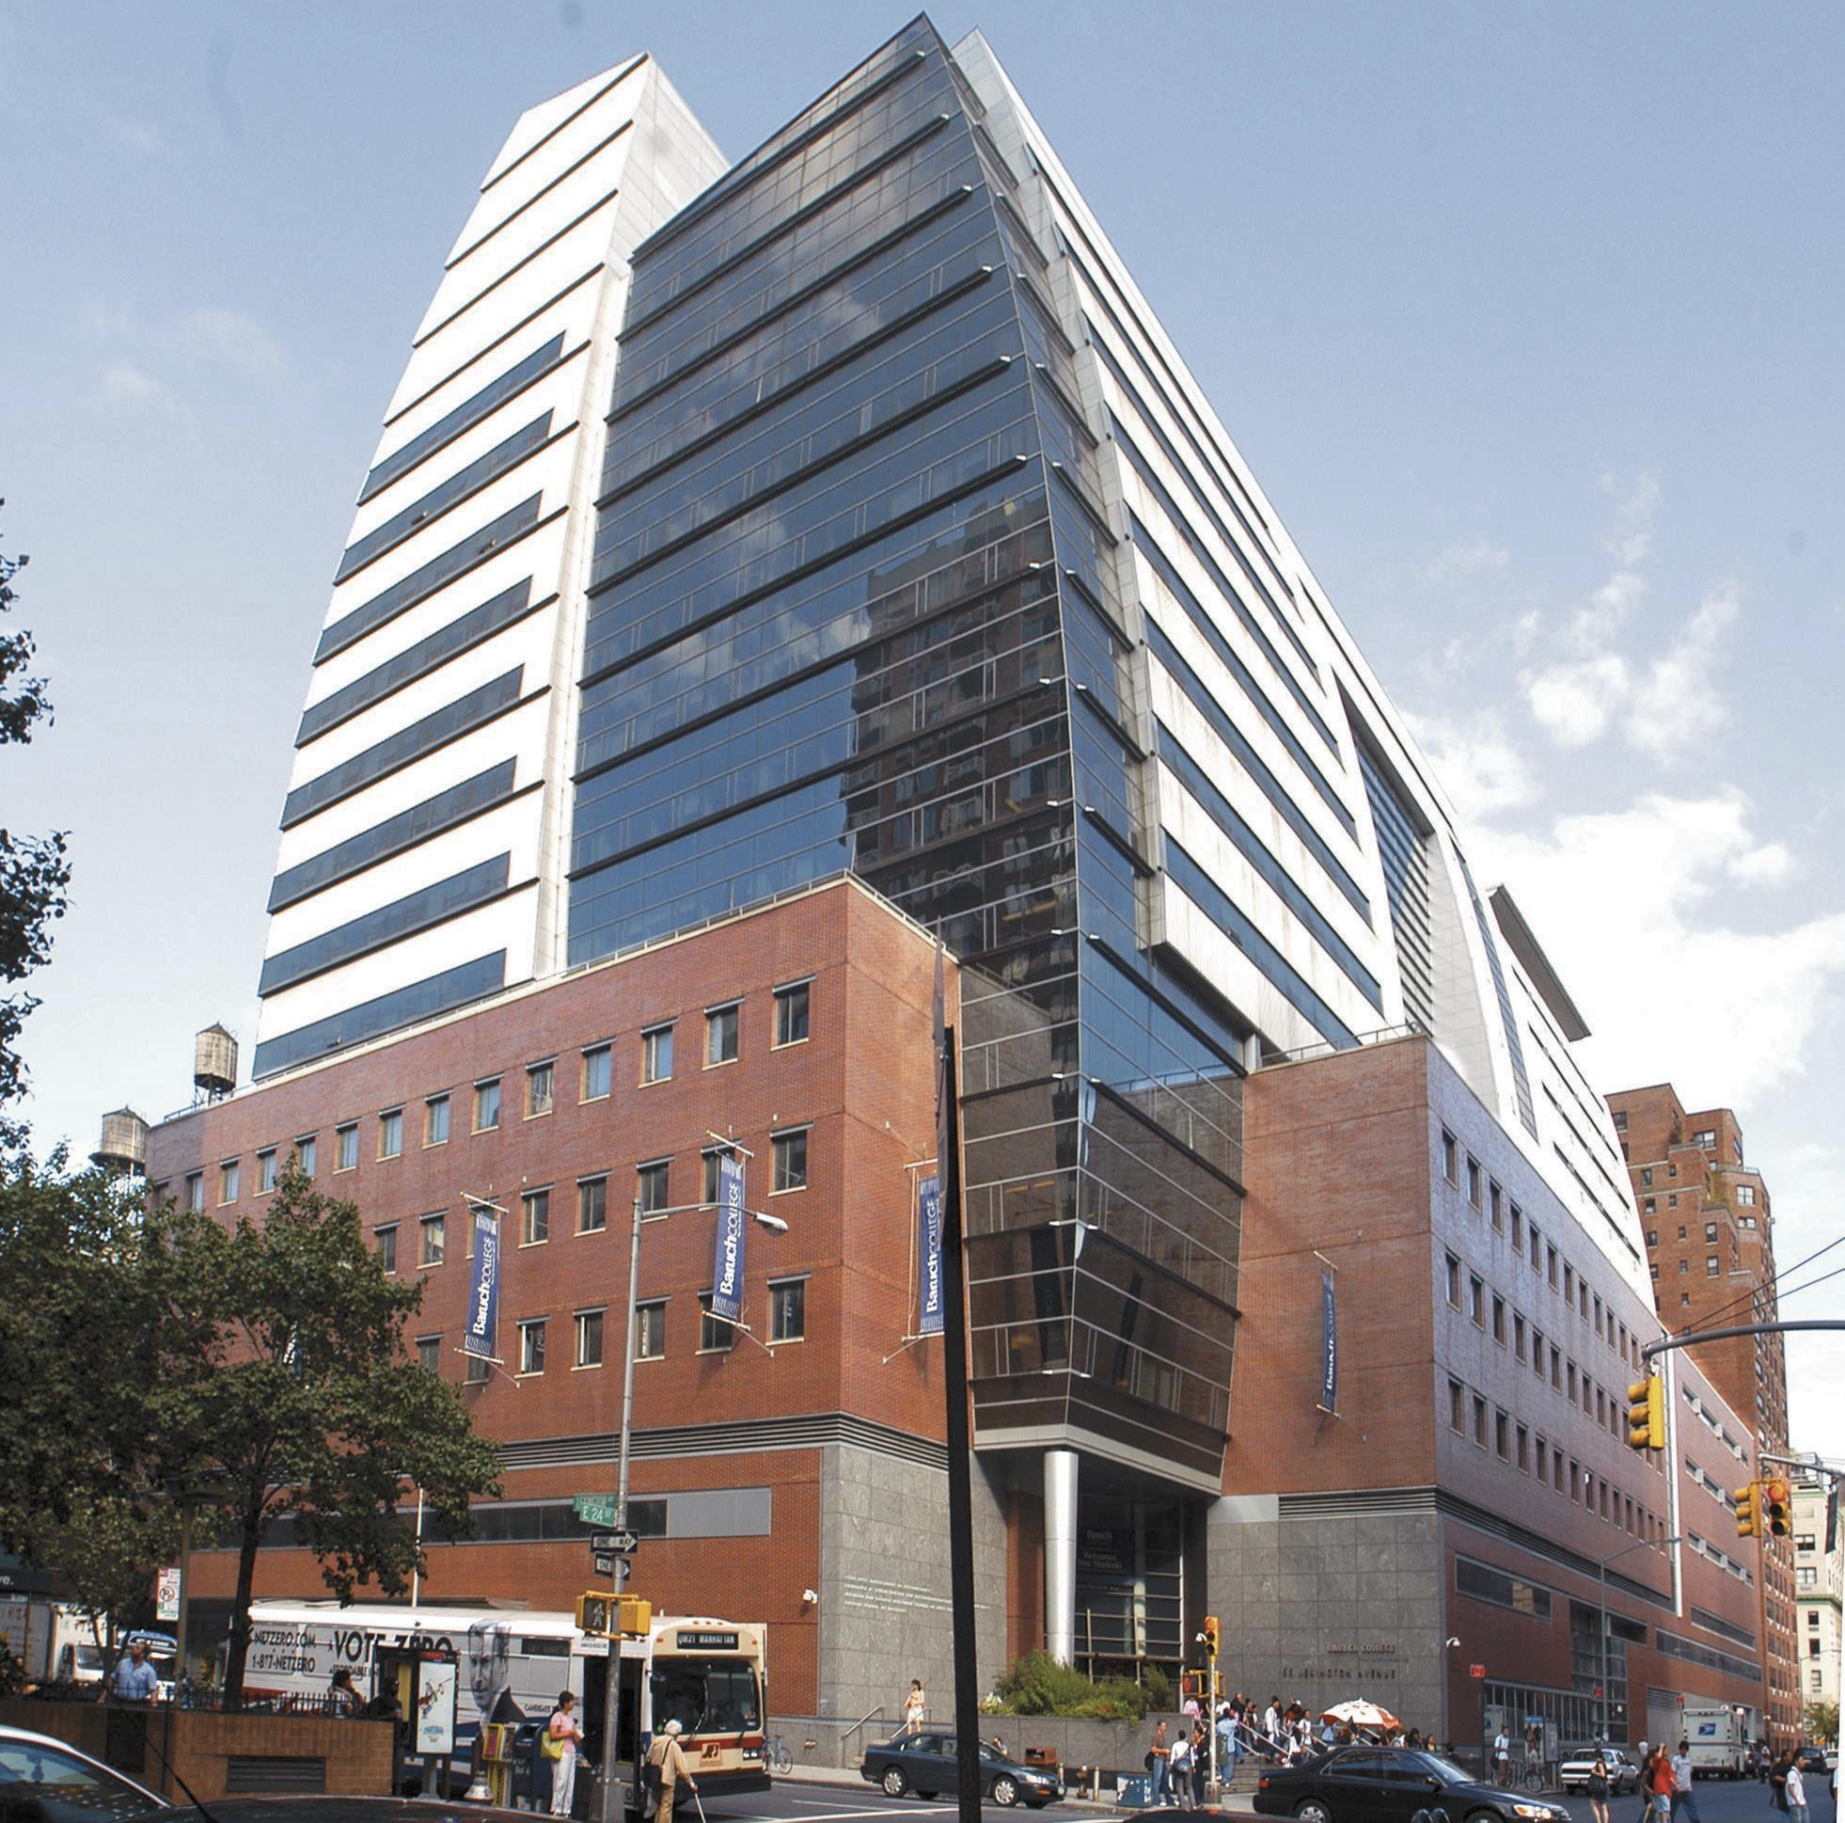

Convener
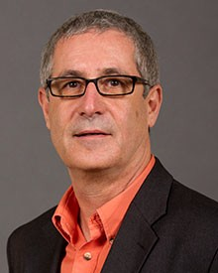

John Casey
55 Lexington Ave, New York, NY 10010 November 19th - November 21st, 2017

Marxe School of Public and International Affairs Baruch College, CUNY
New York, NY

WELCOME LETTER
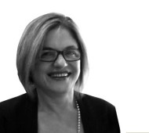

Dear Colleague,

I welcome you to the 15th JCPA and ICPA-Forum Workshop in New York City and as a new valued member of the ICPA-Forum. The International Comparative Policy Analysis Forum and the Journal of Comparative Policy Analysis which pioneered the field of comparative studies since 1998, seek to advance comparative policy studies through publications, workshops, research symposia, scholars’ networks, and interdisciplinary dissemination of knowledge, internationally.

The Annual JCPA and ICPA-Forum Workshops span over two to two and a half days only, are purposefully closed to 10-20 participants at different stages of their careers, focus on one topic specifically defined, and are paper centered offering ample time for presentation, discussants remarks and audience. The rationale behind this format is to ensure intensive fruitful collaboration between participants resulting in topic centered network cohesion, thorough critiques of the papers presented, and facilitation of speedy revisions and submissions to the JCPA. Often the papers presented at the Workshops, become Special Issue articles, following double blind review. Often new comparative research groups form to take the work presented at the Workshop forward.

I wish you a successful and enjoyable time in New York City at our 15th Annual Workshop. We thank the Marxe School at Baruch College and its Dean, Professor David Birdsell, for hosting and Professor John Casey for initiating and convening the Workshop.

Professor Iris Geva-May
Founding President and Editor-in-chief ICPA-Forum and JCPA
www.comparativepolicy.org

Agenda

SUNDAY, NOVEMBER 19TH

6:00 pm: Welcome Dinner
ICPA-Forum and JCPA Welcome Members Meeting
Location: Linen Hall – 101 3rd Avenue, New York NY (between 12th and 13th Street)

MONDAY, NOVEMBER 20TH
Baruch College, Newman Vertical Campus, Room 14-290 (14th Floor) (Corner of Lexington Avenue and 24th Street)

8:30 am: Light Breakfast

9:00 – 9:30: Opening Remarks

David Birdsell (Dean, Marxe School of Public and International Affairs, Baruch College, New York, USA)

John Casey (Marxe School of Public and International Affairs, Baruch College, CUNY, New York, USA)

Iris Geva-May Founding Editor, Journal of Comparative Policy Analysis – JCPA, and Founding President, International Comparative Policy Analysis Forum ICPA-Forum. (SPPA, Carleton University, Ottawa, Canada/The Wagner School, New York University, New York, USA)

9:30 – 10:50: Presentation #1

9:30 – 9:50
The Expansion of Philanthropic Foundations: A Comparative Exploration of Growth Drivers
Marta Rey Garcia (University of A Coruña, A Coruña, Spain)

9:50 – 10:20
Discussants
Jun Han (Georgetown University, Washington D.C., USA) Omoniyi Victor Ajulor (Lagos State University, Lagos, Nigeria)

10:20 – 10:50
Audience Discussion

10:50 – 11:00: Midmorning Break

11:00 – 12:20: Presentation #2

11:00 – 11:20

Does Location and Size Matter? Comparing Third Sector Action in Private Development Aid
Susan Appe (Binghamton University, New York, USA) Fabian Telch (Binghamton University, New York, USA)

11:20 – 11:50
Discussants
Gabriela Vacekova (Masaryk University, Brno, Czech Republic) Cristina Balboa (Baruch College, CUNY, New York, USA)

11:50 – 12:20
Audience Discussion

12:20 – 1:10 Lunch and Get-together

1:10 – 2:30: Presentation #3

1:10 – 1:30
Civil Society Organizations Participation in Policy Implementation for Poverty Reduction in the Rural Africa: A Study of Nigeria
Omoniyi Victor Ajulor (Lagos State University, Lagos, Nigeria)

1:30 – 2:00
Discussants
Lucie Makýšová (Masaryk University, Brno, Czech Republic)
Nadia Rubaii (JCPA & ICPA-Forum, Binghamton University, New York, USA)

2:00 – 2:30
Audience Discussion

2:30 – 2:45: Afternoon Break

2:45 – 5:00: Presentations #4

Thematic Session: Third Sector in China (3 papers)

2:45 – 3:05
Becoming an “Enabling State”? Proactive Purchase-of-Services and Strategic Ignorance in China’s Social Reform
Wen Zhuoyi (Lingnan University, Tuen Mun, Hong Kong)

3:05 – 3:25
Scaling Up Social Organization Ecosystem in China: Three Policy Models
Jun Han (Georgetown University, Washington D.C., USA)

3:25 – 3:45
Rethinking the Corporatism: the New Trend of State-Society Relation in China
Xunyu Xiang (The University of Hong Kong, Pok Fu Lam, Hong Kong)

3:45 – 4:30
Discussants
Stefan Toepler (George Mason University, Virginia, USA) (Discussant” Becoming an “Enabling State”…)
Jerry Mitchell (Baruch College, CUNY, New York, USA) (Discussant for “Rethinking the Corporatism …”)
Joselyn Muhleisen (Baruch College, CUNY, New York, USA) (Discussant for “Scaling up …”))

4:30 – 5:00
Audience Discussion

7:00 PM Workshop Dinner and Members Meeting
Nadia Rubaii, Director of International Institutions Partnerships, ICPA-Forum Iris Geva-May, ICPA-Forum President and JCPA Founding Editor-in-Chief

Announcement of Annual Award for Best Comparative Article in JCPA, Vol. 18, 2016
Joselyn Muhleisen, JCPA Awards Coordinator

Location: Almond – 12 East 22nd Street, New York NY (between Park Ave and Broadway)

TUESDAY, NOVEMBER 21ST
Baruch College, Newman Vertical Campus, Room 14-290 (14th Floor) (Corner of Lexington Avenue and 24th Street)

8:30 am: Light Breakfast

8:45 – 10:05: Presentation #5

8:45 – 9:05
Policy Change and Civil Society in Turkey: Towards a Synthesis of Theories of Collective Action and Policy Processes
Güneş Ertan (Koç University, Istanbul, Turkey)

9:05 – 9:35
Discussants
Bok Gyo Jeong (Kean University, New Jersey, USA)
Marta Rey Garcia (University of A Coruña, A Coruña, Spain)

9:35 – 10:05
Audience Discussion

10:05 – 11:25: Presentation #6

10:05 – 10:25
Fostering Nonprofit Development in Russia: A Regional Comparison
Stephan Toepler (George Mason University, Virginia, USA)

10:25 – 10:55
Discussant
Xunyu Xiang (The University of Hong Kong, Pok Fu Lam, Hong Kong) Susan Appe (Binghamton University, New York, USA)

10:55 – 11:25
Audience Discussion

11:25 – 11:40: Mid-morning break

11:40 – 1:00: Presentation #7

11:40 – 12:00
Third Sector Expansions in (Post-) Transitive Economies of Central and Eastern Europe
Gabriela, Vacekova (Masaryk University, Brno, Czech Republic) (Jana Soukopová (Masaryk University, Brno, Czech Republic) Lucie Makýšová (Masaryk University, Brno, Czech Republic)

12:00 – 12:30
Discussants
Güneş Ertan (Koç University, Istanbul, Turkey)
Wen Zhuoyi (Lingnan University, Tuen Mun, Hong Kong)

12:30 – 1:00
Audience Discussion

1:00 – 2:15 Lunch and Keynote Session

KEYNOTE SPEAKER: Kathleen D. McCarthy
Director, Center on Philanthropy and Civil Society, CUNY Graduate Center, New York, USA
“Reflections from a Primary Source.”

2:15 – 3:35: Presentation #8

2:15 – 2:35
Mobilizing Social Enterprises as Public Policy Tools: Hybrid Social Welfare Regime in East Asia
Bok Gyo Jeong (Kean University, New Jersey, USA)

2:35 – 3:05
Discussants
Fabian Telch (Binghamton University, New York, USA)
John Casey (Marxe School of Public and International Affairs, Baruch College, CUNY, New York, USA)

3:05 – 3:35
Audience Discussion

3:35 – 4:00 Closing Remarks and Planning for the Prospect of a Special Issue in the JCPA

John Casey (Marxe School of Public and International Affairs, Baruch College, CUNY, New York, USA) Nadia Rubaii, Director of International Partnerships, (JCPA and ICPA-Forum, Binghamton University, New York, USA)
Leslie Pal, JCPA Executive Editor (Carleton University, Canada) (via Skype) Diana Walker, Editorial Manager (Simon Fraser University, Canada) (via Skype)

FREE EVENING

ADDITIONAL EVENTS

- Annual Ackerman Lecture on Social Justice, one of MSPIA Baruch College signature public events.
Latinos and the Endangered Right to Vote
JUAN CARTAGENA (President & General Counsel of Latino Justice PRLDEF, one of the nation's leading civil rights public interest legal organizations).
The William and Anita Newman Vertical Campus, Room 14-220
5:00 – 5:30 pm Reception; 5:30 – 7:30 pm Lecture and Q&A

- TOURS IN NEW YORK CITY: We will be organizing optional tours and visits for those staying in New York on Tuesday or after. Please contact JCPA &ICPA-Forum Executive Secretary, Courtney Scott at courtneyscottmpa@gmail.com

CONTACT INFORMATION

Authors
Omoniyi Victor Ajulor Omoniyiajulor@gmail.com Susan Appe sappe@binghamton.edu
Güneş Ertan gunesertan@ku.edu.tr Jun Han Jun.Han@georgetown.edu Bok Gyo Jeong bjeong@kean.edu Lucia Makýšová 402978@mail.muni.cz Marta Rey-García martarey@udc.es
Jana Soukopová jana.soukopova@econ.muni.cz Fabian Telch ftelch1@binghamton.edu
Stefan Toepler, stoepler@gmu.edu
Gabriela Vacekova gabriela.vacekova@econ.muni.cz Xunyu Xiang xunyu@connect.hku.hk
Wen Zhuoyi wenzhuoyi@msn.com

JCPA-ICPA Representatives
Iris Geva-May gevamay.i@gmail.com Nadia Rubaii jcpa.icpaforum@gmail.com
Courtney Scott courtneyscottjcpaicpa@gmail.com Joselyn Muhleisen Joselyn.muhleisen@baruch.cuny.edu

Baruch College
David Birdsell David.birdsell@baruch.cuny.edu Cristina Balboa Cristina.Balboa@baruch.cuny.edu John Casey john.casey@baruch.cuny.edu
Jerry Mitchell jerry.mitchell@baruch.cuny.edu Joe Moran joseph.moran1@baruchmail.cuny.edu

